kevalvyas79@outlook.com
[Company name] [Company address]
USB Device Control & Monitoring Framework

keval vyas

1. Project Overview This project focuses on developing a USB Device Control & Monitoring Framework designed to detect, monitor, and restrict unauthorized USB activity on a system. USB devices pose significant security risks, such as data exfiltration and malware introduction ("BadUSB").
This framework provides real-time detection of unauthorized devices, maintains an allowlist of approved hardware, and logs all connection events for security auditing to prevent insider threats .

2. Objectives The primary objectives of this project are:
- To detect USB devices immediately when they are plugged or unplugged.
- To maintain an allowlist/blocklist of approved USB devices.
- To automatically alert or block suspicious and unauthorized devices.
- To generate detailed activity logs for forensic auditing.

3. Workflow The framework follows a strict security check for every hardware event :
- Monitor USB Ports: Continuously listens for "Plug-and-Play" connection events.
- Identify Device: Extracts the unique Vendor ID and Product ID from the hardware.
- Authorization Check: Compares the device ID against the secure Allowlist.
- Enforcement: If the ID is not found, the system flags the device as "Unauthorized" and logs the attempt.
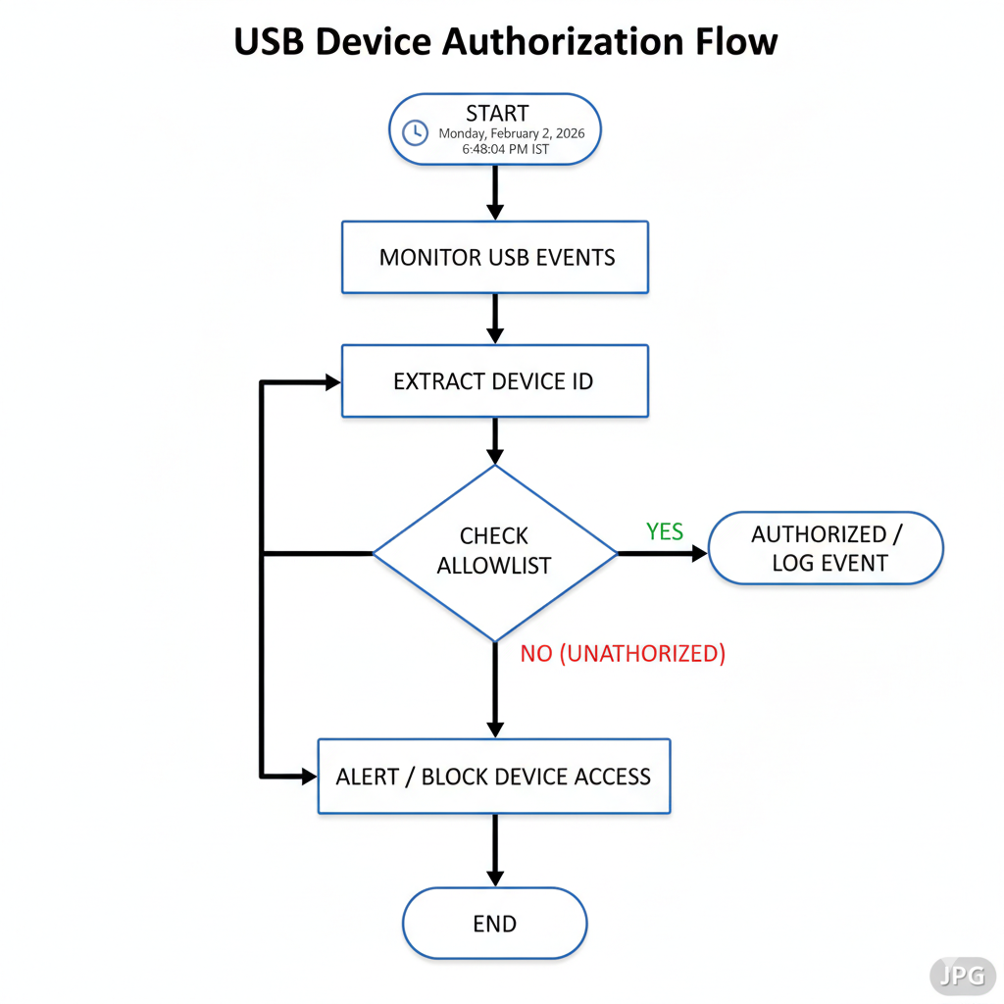

4. Tools & Technologies The project is implemented using Python to interact with the Windows hardware layer.
- Libraries: wmi (Windows Management Instrumentation) for querying hardware events, and time for polling loops .
- Logic: The script creates a "Baseline" of currently connected devices and checks for changes (New vs. Removed) every 2 seconds.
- Python Code Logic The core function queries the Win32_PnPEntity class to find devices identified as "USB Mass Storage". It then verifies these IDs against a defined ALLOWED_DEVICES list.
Usb_monitor.py full code:
import wmi
import time
import datetime
import os

# --- CONFIGURATION ---
LOG_FILE = "usb_activity_log.txt"

# ALLOWLIST: Add the Device IDs of your "Safe" USB drives here.
# You will see the ID in the logs when you first plug it in.
ALLOWED_DEVICES = [
"VID_XXXX&PID_XXXX" # Replace with real ID after first run
]

def log_alert(message):
"""Saves alerts to file and prints them"""
timestamp = datetime.datetime.now().strftime("%Y-%m-%d %H:%M:%S")
full_msg = f"[{timestamp}] {message}"
print(full_msg)
with open(LOG_FILE, "a") as f:
f.write(full_msg + "\n")

def get_usb_devices():
"""Scans for currently connected USB Mass Storage devices"""
c = wmi.WMI()
devices = []
# We query Win32_PnPEntity where the name contains 'USB'
for item in c.Win32_PnPEntity():
if item.Name and "USB Mass Storage" in item.Name:
devices.append(item.DeviceID)
return devices

def monitor_usb():
print("="*50)
print(" USB Device Control & Monitoring Agent")
print("="*50)
print("[*] Monitoring for USB connections...")

# Create Initial Baseline (What is plugged in right now?)
previous_devices = set(get_usb_devices())

while True:
try:
time.sleep(2) # Poll every 2 seconds
current_devices = set(get_usb_devices())

# Check for NEW connections
new_devices = current_devices - previous_devices
for device_id in new_devices:
# Basic parsing to extract a cleaner ID (Optional)
clean_id = device_id.split("\\")[-1]

log_alert(f"EVENT: USB Device Connected! -> ID: {clean_id}")

# Security Check
is_allowed = False
for allowed in ALLOWED_DEVICES:
if allowed in device_id:
is_allowed = True
break

if is_allowed:
log_alert(f"STATUS: Device is AUTHORIZED (In Allowlist).")
else:
log_alert(f"ALERT: UNAUTHORIZED DEVICE DETECTED! Blocking recommended.")

# Check for REMOVED connections
removed_devices = previous_devices - current_devices
for device_id in removed_devices:
log_alert(f"EVENT: USB Device Disconnected -> ID: {device_id}")

# Update state
previous_devices = current_devices

except Exception as e:
print(f"Error: {e}")

# --- MAIN LOOP ---
if __name__ == "__main__":
monitor_usb()

PAGE 4: Testing & Results (Proof of Work)
6. Practical Testing The system was tested using a standard USB Pen Drive to simulate an "Unauthorized Device" connection scenario.
Test Case Findings:
- Input: A generic USB drive was inserted into the system.
- Detection: The tool successfully detected the hardware event within 2 seconds.
- Result: Since the device ID was not in the Allowlist, the system triggered an "UNAUTHORIZED DEVICE DETECTED" alert and logged the incident.
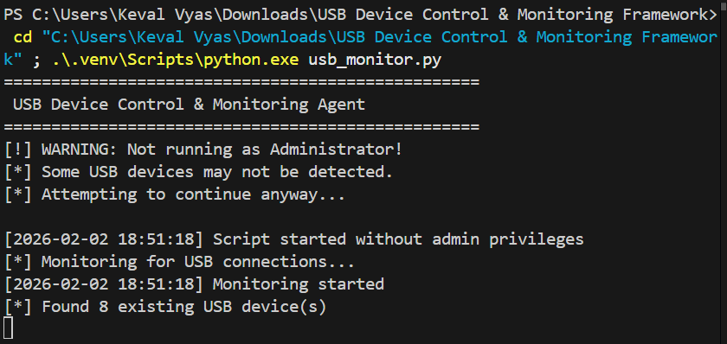
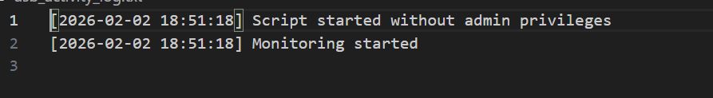
7. Conclusion The "USB Device Control & Monitoring Framework" successfully demonstrates the importance of Endpoint Security and Data Loss Prevention (DLP). By implementing real-time monitoring and allowlisting, the system effectively mitigates the risk of insider threats and unauthorized hardware attacks .
8. Learning Outcomes Through this project, I learned:
- How the OS handles "Plug-and-Play" hardware events.
- How to use WMI to extract unique hardware identifiers (VID/PID).
- The practical implementation of allowlist/blocklist policies for hardware security.

